List tools used to achieve the 5 phases of ethical hacking from Kali Linux and create a Word document with screenshots

Reconnaissance
- Nmap

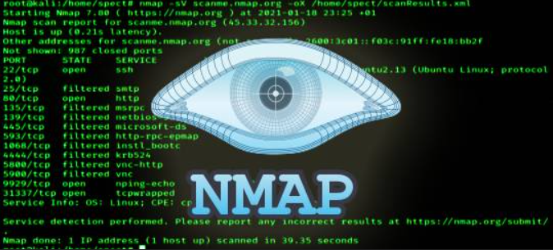
- Maltego
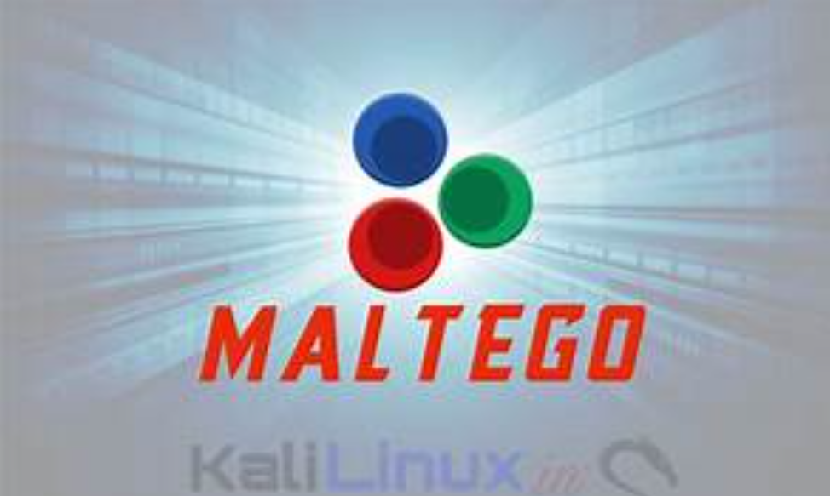
- Theharvester

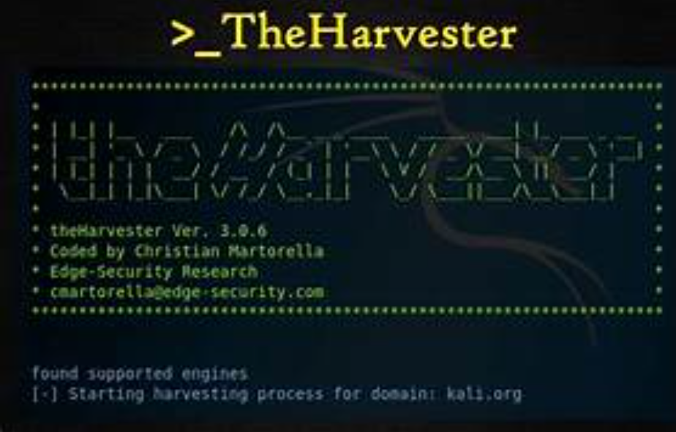

Scanning & Enumeration
- Nikto
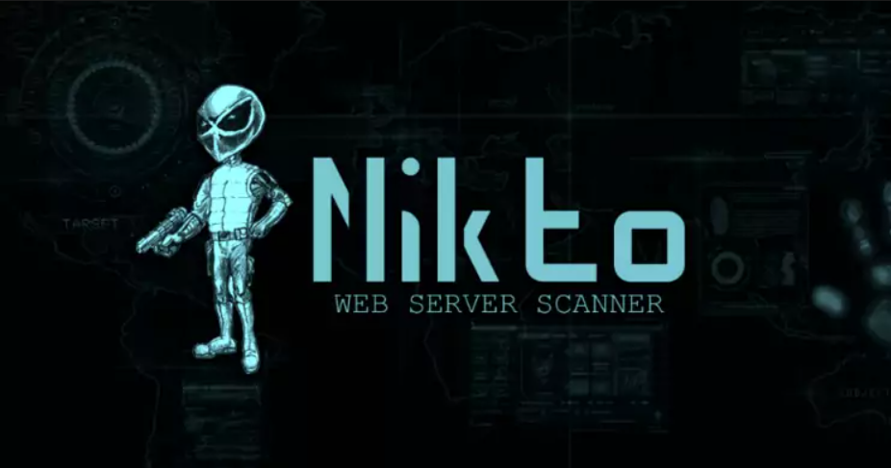
- Open Vas
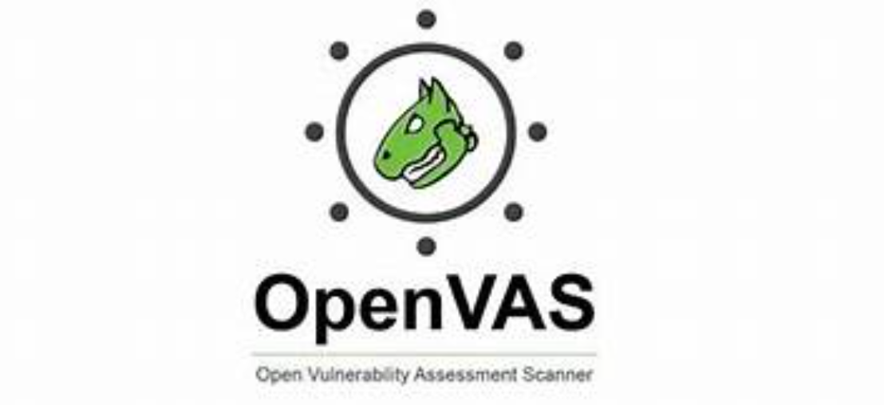

3.Gaining Access
- Metasploitable Framework
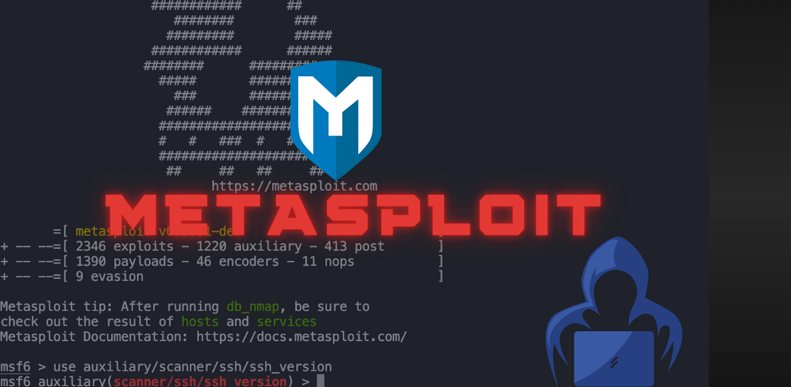
- SQLmap

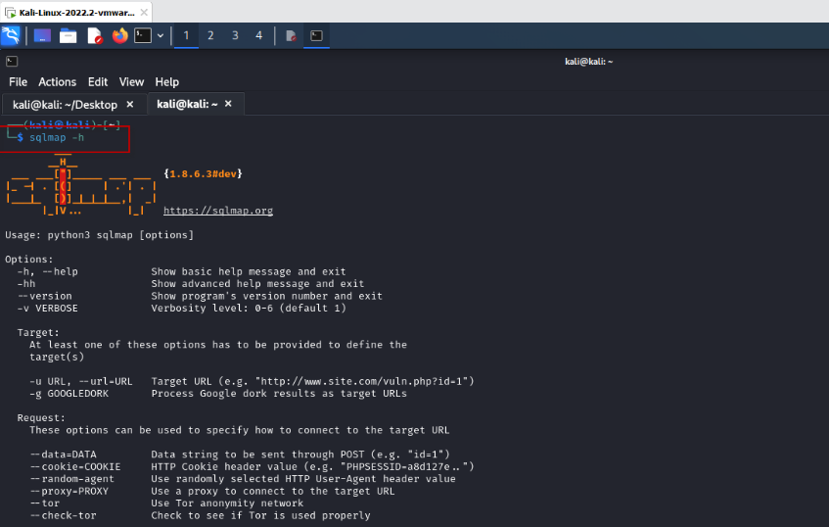

Maintaining Access
- Weevely

- SSH Key
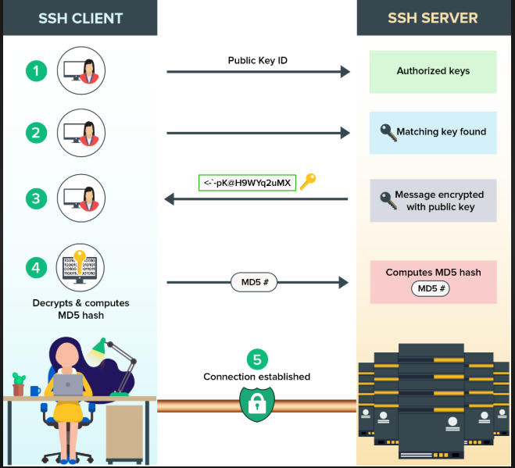

Covering Tracks
- Metasploit Timestomp
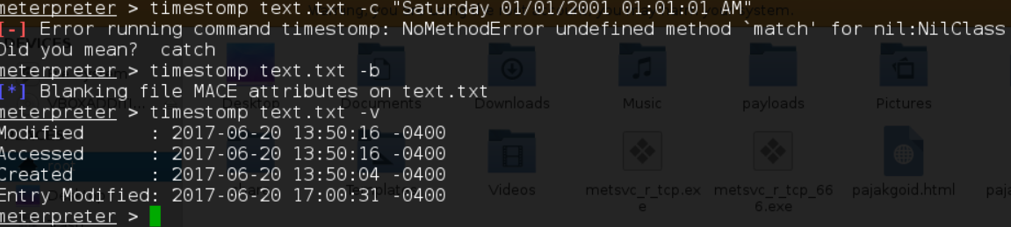
- Logcleaner scripts
